Name: Kerollos Eid afraiem

B.N: 144

E-Mail:kerolus190026@feng.bu.edu.eg

Topic: Mobile Computing

Githup link:

Page link:

**Abstract**

**Mobile Computing is A technology that is capable of providing an environment which enables users to transmit data from one device to other device without the use of any physical link/cables. Mobile devices may be linked to a neighborhood called the Local Area Network (LAN). There are many devices such that; Personal Digital Assistant (PDA0, Smartphones, Tablet PCs.**

**Mobile Computing has many applications in life for example: Credit Card Verification, In Education feiled, In Medical field, n banking field and In Airline industry. Inaddition it is has important benefits such that;** **Increasing productivity, Entertainment, Portability, Cloud Computing, Location Flexibility, Saves Time.**

**Programming languages are used for the software for the mobile system. Operating system functions to run components of the software onto the hardware. Deployment of middleware components. Uses layered structure arrangement of components for mobile computing.**

**There are many types of mobile devices, including RIM devices, cellular phones , PDAs, tablets , computers, and laptop computers. These mobile devices can normally be used as thin clients or as fat clients, or they can be developed to host web pages.**

**Mobile devices have similar characteristics. Among them are:**

* **Wi-Fi or cellular access to the internet**
* **A battery which is powering the device for several hours**
* **Size and weight which enables it to be carried in one hand and manipulated in the other**
* **Internet data downloading capability, including apps and books Wireless mode**
* **A virtual assistant, like Siri, Cortana or Google Assistant**

**Pages**

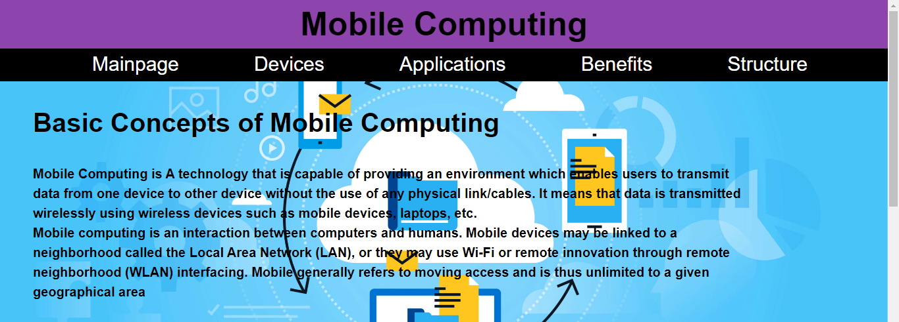

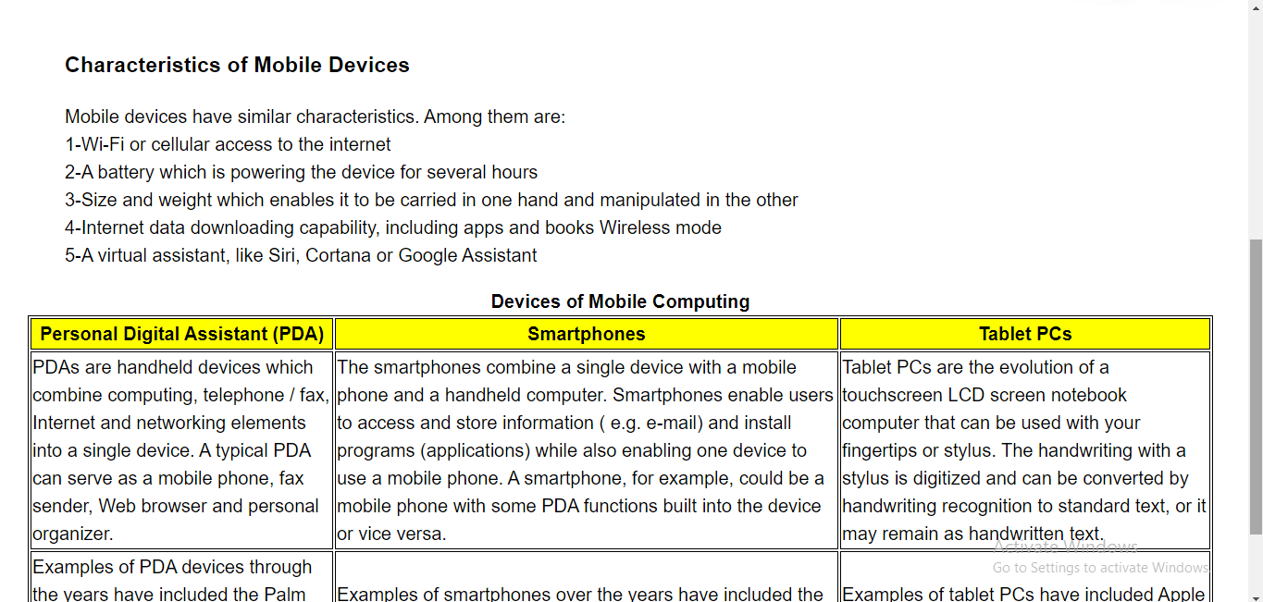

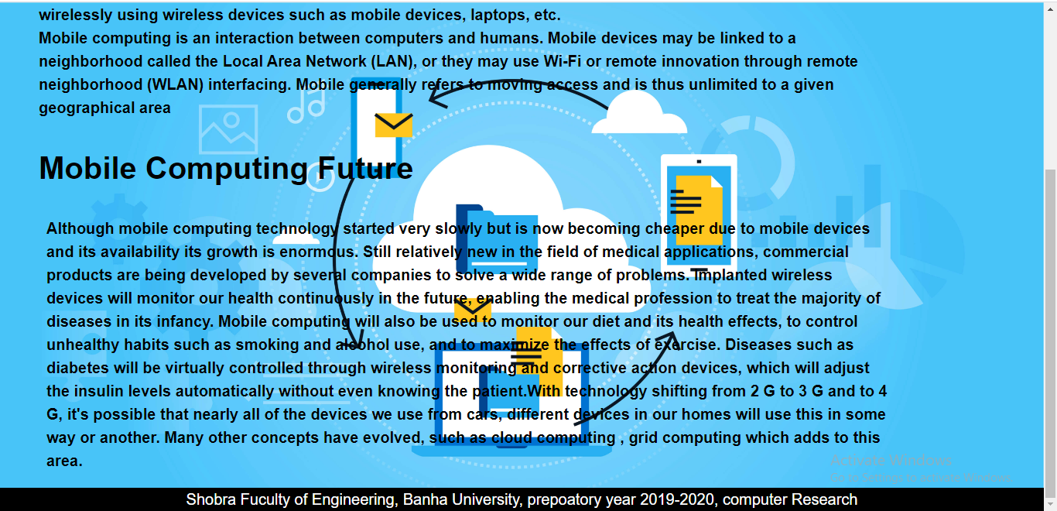

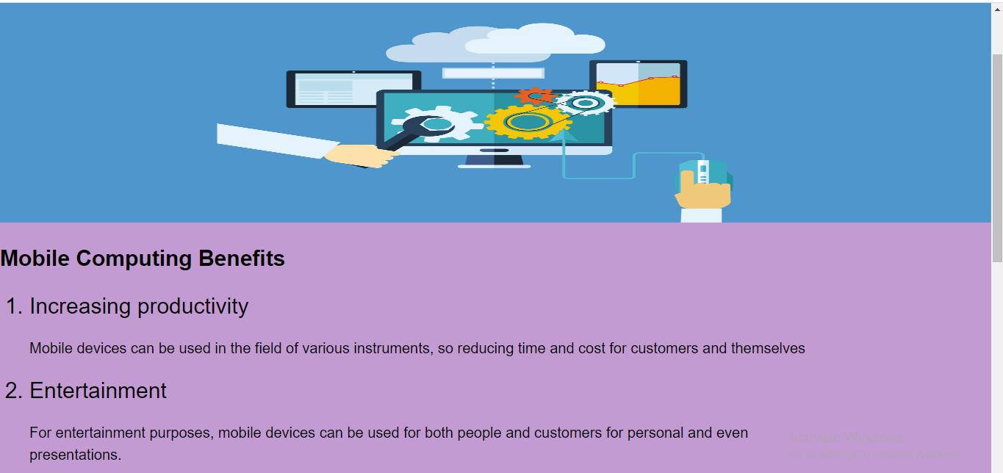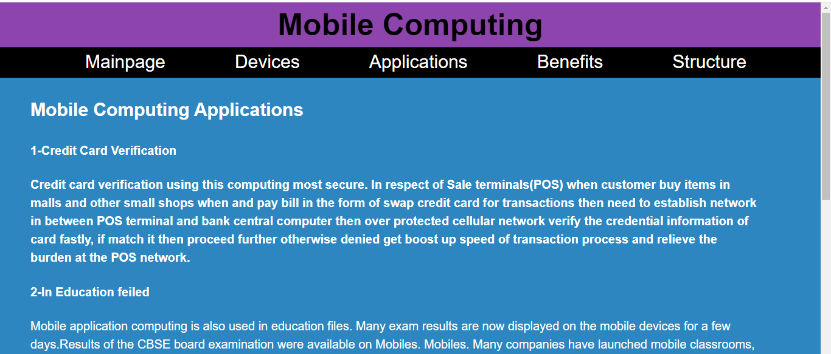

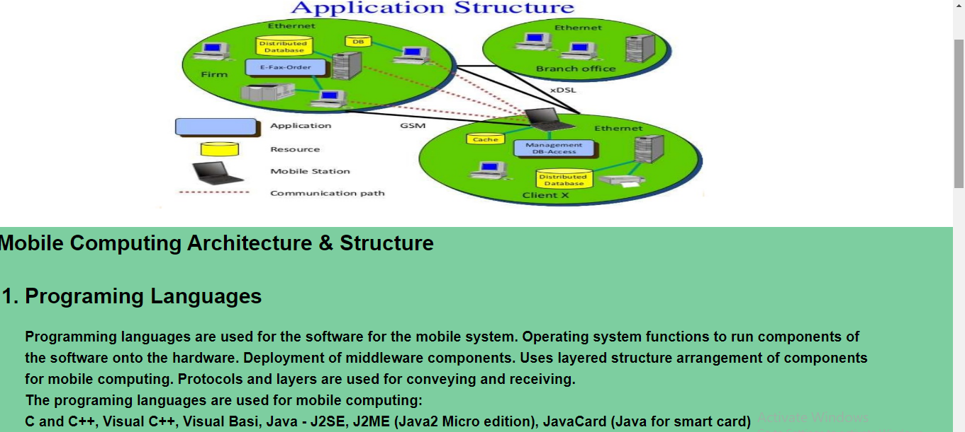

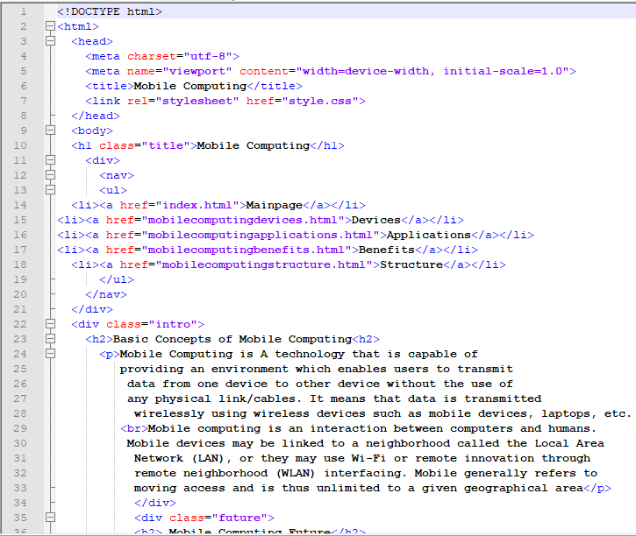 **codes**

